**[Indian Institute of Technology, Guwahati](https://www.iitg.ac.in/)**

**A**

**PROJECT**

**REPORT**

**ON**

**BINARY CODED GENETIC ALGORITHM**



**Submitted to: Submitted by:**

Dr. Sukhomay Pal Manpreet Singh

204103313

**Department of Mechanical Engineering, IITG**

**Binary Coded Genetic Algorithm**

1. **Introduction to Genetic Algorithm**

A genetic algorithm is a population based search technique used in computing to find true or approximate solutions to optimization and search problems.

Genetic algorithms are categorized as global search heuristics. Genetic algorithms are a particular class of evolutionary algorithms that use techniques inspired by evolutionary biology such as inheritance, mutation, selection, and crossover.

1. **Binary Coded Genetic Algorithm**

In binary coded GA, a gene or chromosome is represented by a string of binary bits (0’s and 1’s). The size of string depends upon the variable range and desired accuracy

1. **Given Problem Statement -**

Develop a generalize computer program for a binary-coded GA with Roulette-wheel reproduction scheme, two point crossover and bit-wise mutation.



1. **Features of General Python Code developed -**

* Can handle n number of variable problems 

* Can handle both maximization and minimization problems
* The desired accuracy of each variable can be defined independently

1. **Flow Chart of Python Code -**



1. **Natural Selection Operator:**

With this approach the population after mutation (off spring population) is combined with parent population and then out of total combined population top N solution are selected based on the Ranking of Fitness value. Which further is considered for next generation

This operator is also known as “Survival of Fittest”, which pass on only best solution after crossover and mutation to next generation

Objective - Minimization of two variable problem with given geometric constrains

Input parameters:-

Population Size (N) = 20

Max Generation Limit = 200

Cross over Probability (Pc) = 0.9

Mutation Probability (Pm) = 0.5

Desired accuracy of each variable (e) = 0.0001

Fitness v/s generations Plot-

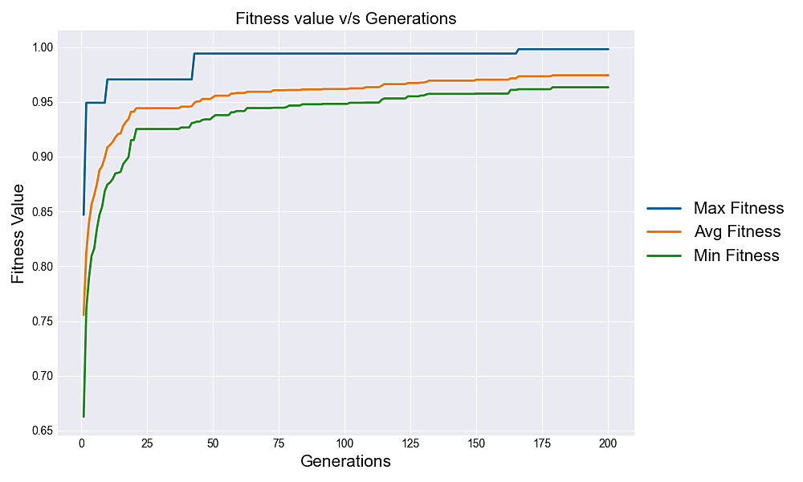

Solutions of different generations on objective function’s contour plot-

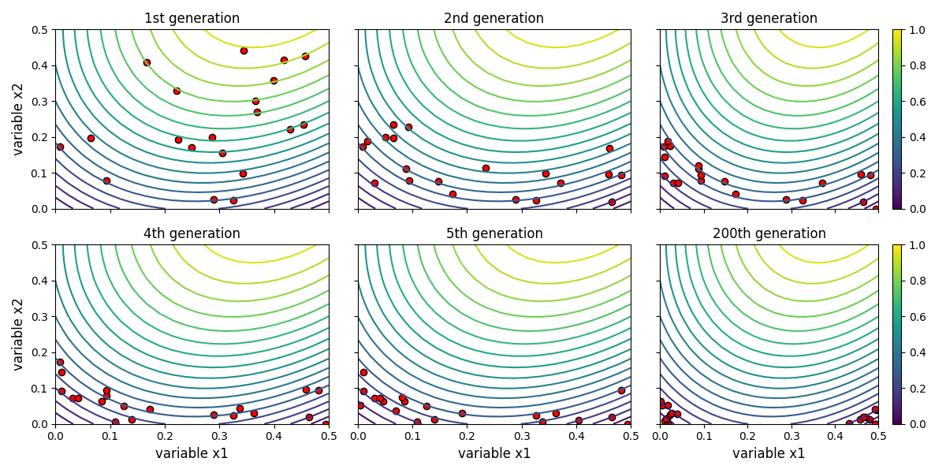

From above plot we can see the binary coded genetic algorithm converge to optimum solution very quickly as shown by the scatter plot on objective function’s contour plot. Looking at the variation in solutions over generation we can see the at 200th generation the solutions form two cluster around optimum solutions

Optimum value of Solutions from Binary coded GA:

1. 
2. 
3. **Conclusion:-**

Plot of genetic algorithm shows convergence rate to optimal Solution, if there are multiple optimal solution it is capable to finds all of those. For given problem there are two optimal solution and final generation of GA is forming cluster about those optimal solutions.